### Make Prescription

* Summary: This diagram show process of doctor to make prescription to patient.

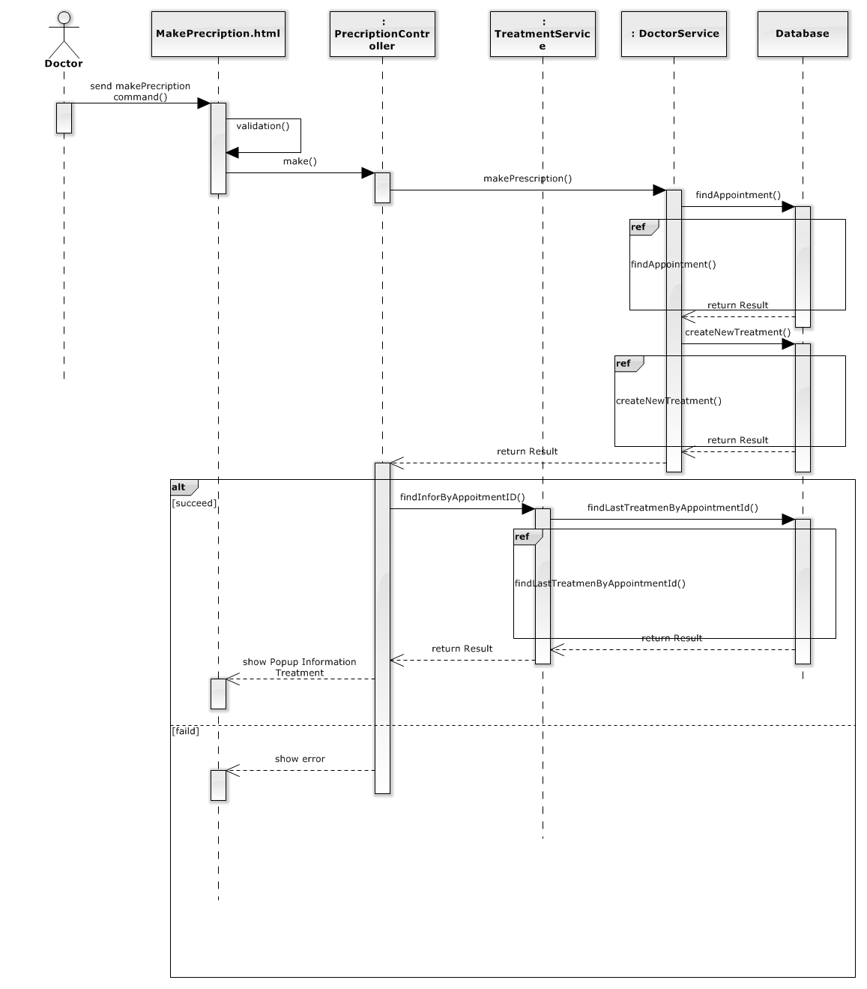

#### findAppointment()

#### D:\Sequencediagram3.png

#### createNewTreatme()

#### D:\Sequencediagram4.png

#### findLastTreatmenByAppointmentId()

#### D:\Sequencediagram5.png

### <Doctor> View Patient Medical History

* Summary: This diagram show process of Doctor view medical history of patient.

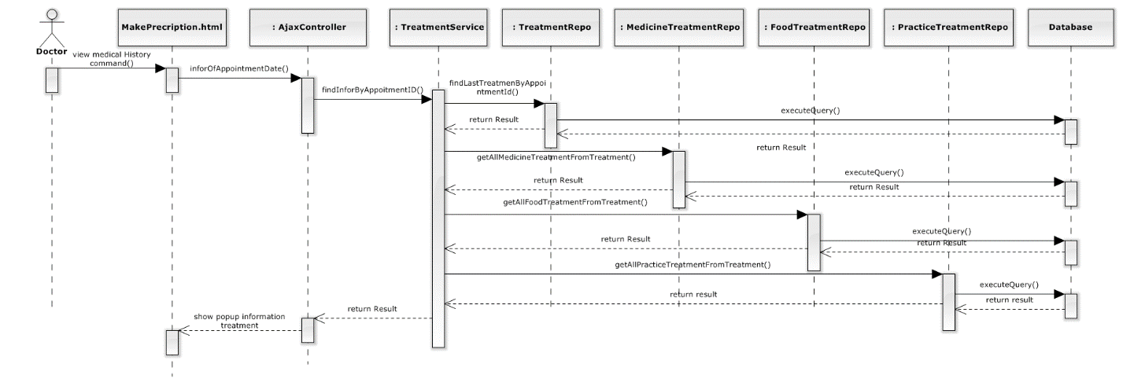

### < Analyst > Suggest Treatment

* Summary: This diagram show process of analyst suggest treatment for doctor.

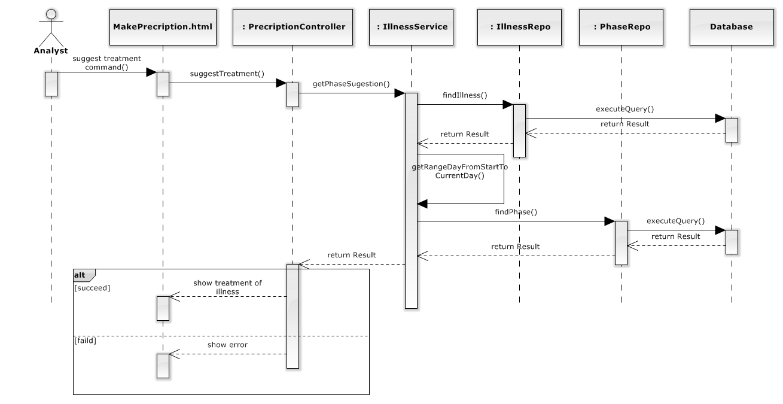

### <Nutrition Doctor> Create nutrition survey.

* Summary: This diagram show process of nutrition doctor to create nutrition survey to patient.

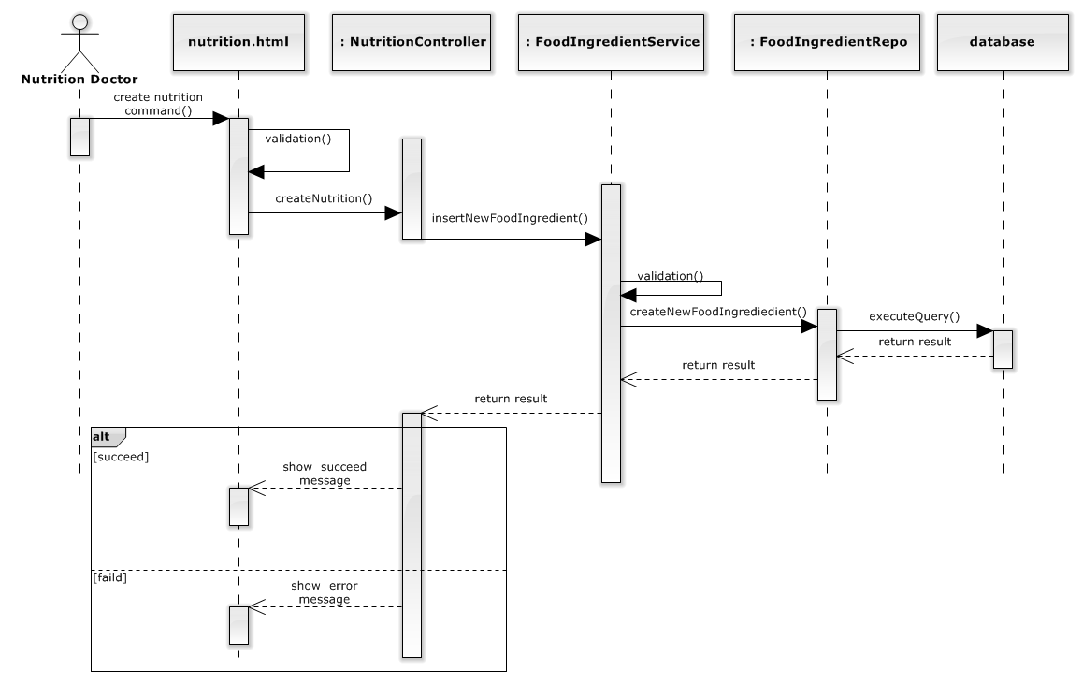

### Insert food

* Summary: This diagram show process of nutrition doctor to create food .

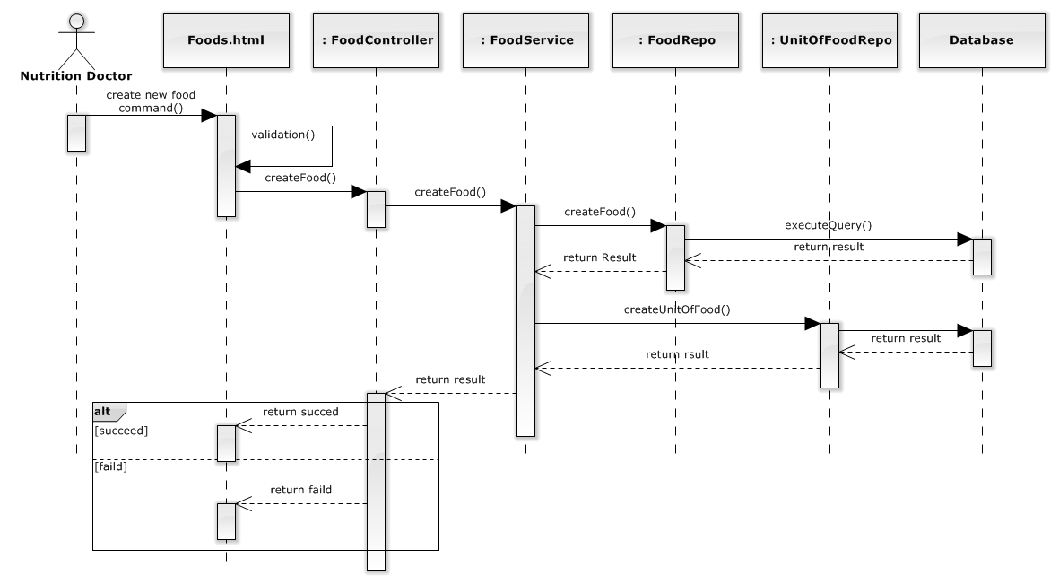

1.6 update food

* Summary: This diagram show process of nutrition doctor to update information of food.

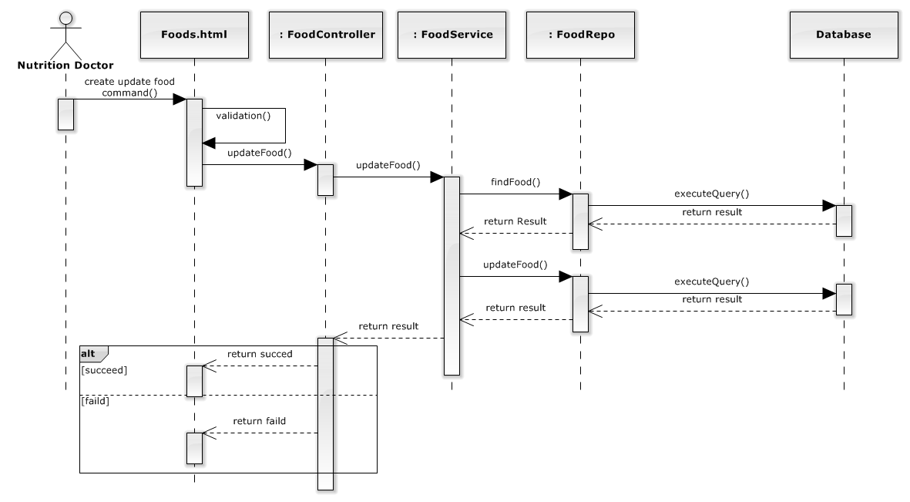

* 1. Delete Food

Summary: This diagram show process of nutrition doctor to delete food.

